**Laudato Si’ Reflection  
  
What I See?**

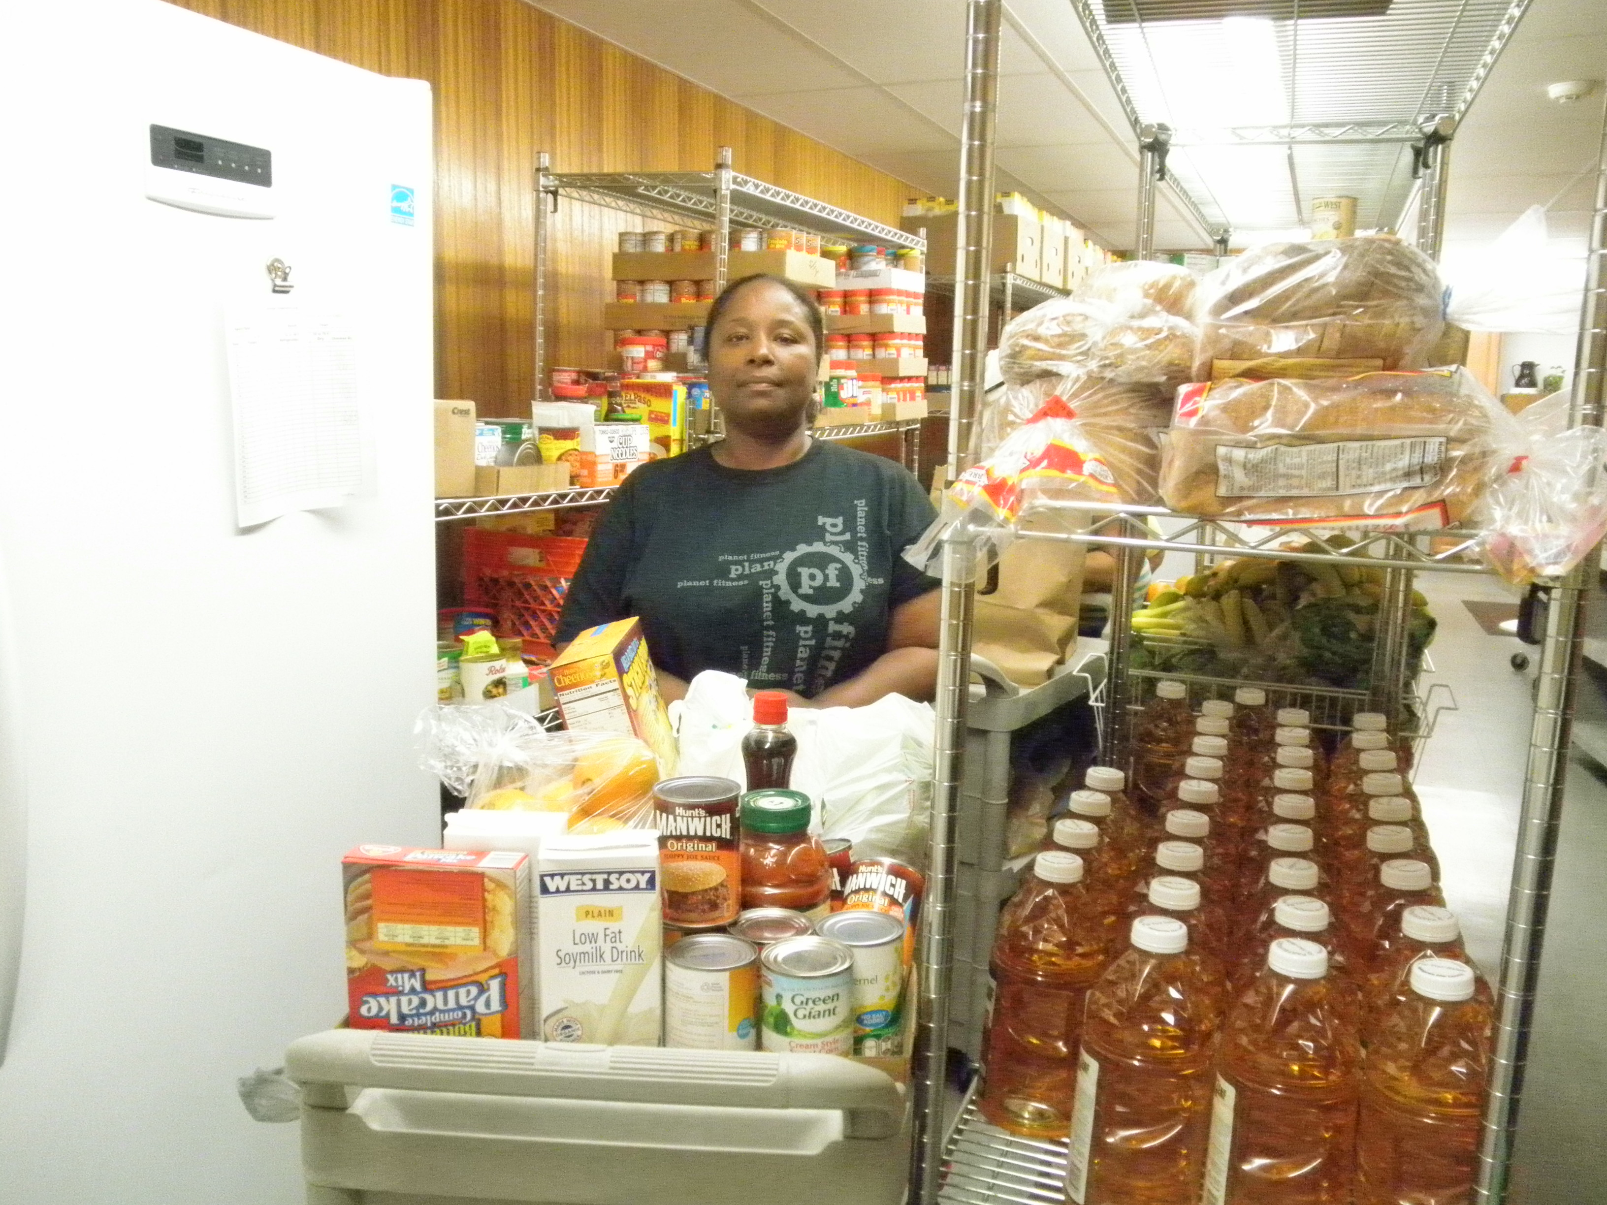

Mostly brown people, especially women, line up to choose the food they need from our Bernardine Franciscan Sisters’ food pantry in Chester, Pennsylvania. They choose from options based on the availability of healthy foods that have been donated or purchased; the amount each month is based on the size of their household/family. The food items are basic and varied, but not generally the more expensive “brand name” items. Most persons leaving the pantry with their boxes of food are expressively grateful to the volunteers who assist them. These women live in a society that is not friendly towards their needs. There are limited work opportunities at very low wages for women who also need to manage their households, work full time, and care for children and older parents. Their travel is limited to the nearby bus route, since most don’t have access to cars for travel.

In contrast, I look at my own personal purchases of food and at the meals that may be prepared for me. Do I choose to indulge in the best and more expensive foods? Am I critical of what another prepares for me? Do I complain in the supermarket criticizing the available choices on the food shelves? Do I eat more than my share or more than my need? I reflect on my personal opportunities for dignified work that pays a just salary, at my access to a car for transportation needs and wants. How am I different from the women I meet at the food pantry? Is it society that creates the barriers and challenges for some women and not others? Am I a partner in that social structure that engages some women but neglects others because of color, race, education, or even personality? How do I speak for those who have no voice or for those who have been punished for speaking out?

**How I Judge?**

It is significant that most women who are poor value what little they receive, while those of us with more resources may at times express disappointment even though we have more than what we need. In our Laudato Si’ Commitment Statement, we say we commit to “adopting a simpler more sustainable lifestyle,” but, in fact, don’t we often expect the most up-to-date electronics to accomplish our work and crave constant access to technology for immediate connections with employees, family and friends. Are we a part of the societal structure that relegates some women to poverty by our attitude and self-indulgence, by our self-centeredness, or by our misunderstanding of inclusiveness and cultural diversity? Or are we merely selfish or even blind to the challenges, suffering, hunger, and homelessness of many whom we walk by on a daily basis?

**How I Act?**

As we Bernardine Franciscan Sisters pledge in our Laudato Si’ Commitment Statement to “reduce our negative impact on the environment and to address injustices in our world, we might reflect on our frequent expressions of in-gratitude when our particular expectations are not met to the degree to which we want, as compared to those many persons around the world who have far less in the way of food, water, shelter, available livelihoods, and even travel options.

Do we too frequently act like we are the only valued persons on the planet and all is ours for pleasure and experience. Are we not held to the mandate of Jesus who invites us all to the table? **How might we include all peoples at Earth’s Table? This is our call to Laudato Si’.**

Some concrete actions that may help us remember the needs of others on Earth:

Plant varieties of natural habitat trees on our properties to enhance the removal of carbon dioxide from our environment. Remember the deforestation of the Amazon Rain Forest and let us help repair it.

Purchase food and other products that are not heavily packaged in throw-away materials. This saves on the amount of damaging trash that builds up our landfills creating noxious smell and pollution that in turn, causes cancer and other physical ailments for humans and destroys environmental biomes.

Unify as a group to choose at least one day each week as a day of meatless meals recognizing that more of Earth’s resources are destroyed when greater amounts of land are gutted for the production of meats than it takes for growing and harvesting vegetables for human consumption. (Problems with meat production include: increasing water pollution, growing feed for animals instead of humans, increasing toxic gaseous emissions, loss of forests and increasing CO2 in atmosphere).

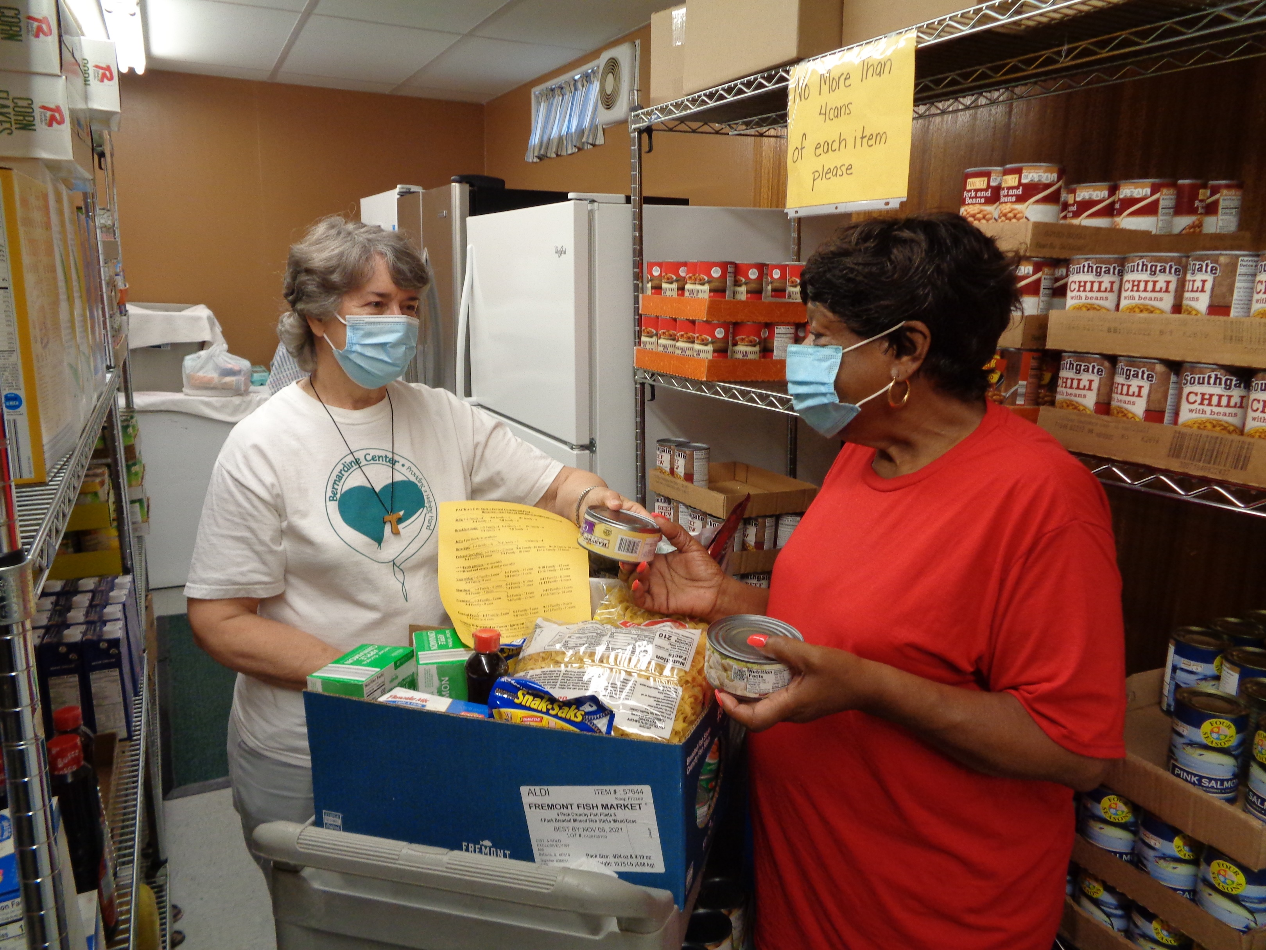

Reflection by:

Sandra Lyons, OSF   
Congregational Councilor  
Office of Justice, Peace and Integrity of Creation