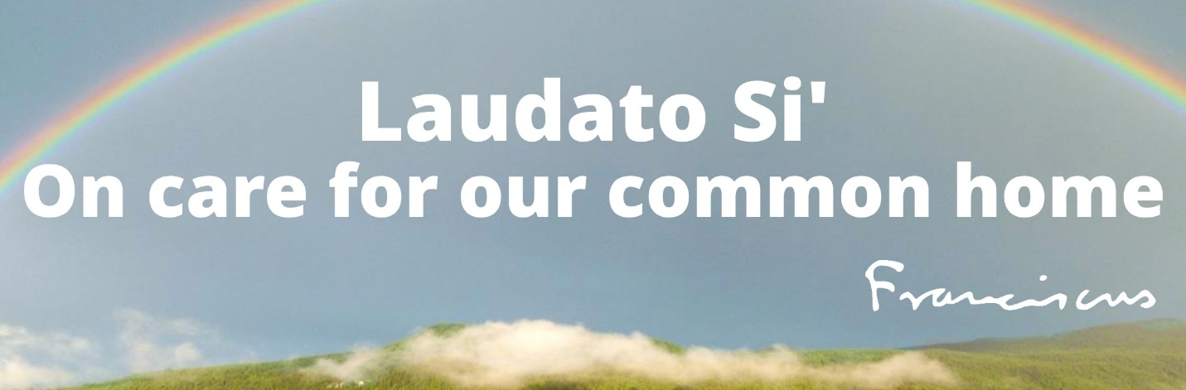
CREATION CARE CONVENANT

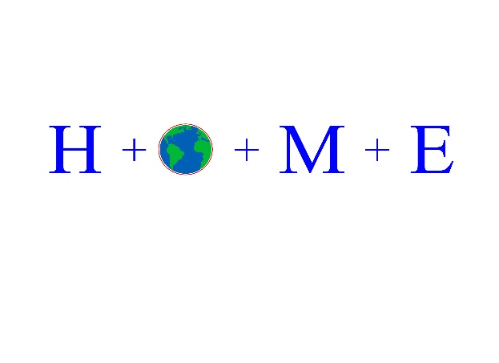

Creation Care Covenant
In Laudato Si’, Pope Francis mandates the following: “All of us can cooperate as instruments of God for the care of creation, each according to his/her own culture, experience, involvements and talents.” (#14)
In 2001,the United States Conference of Catholic Bishops issued a statement calling all Catholics to respond to the climate crisis. The following is a section of that document.
As people of faith, we are convinced that "the earth is the Lord's and all it holds" (Ps 24:1). Our Creator has given us the gift of creation: the air we breathe, the water that sustains life, the fruits of the land that nourish us, and the entire web of life without which human life cannot flourish. All of this God created and found "very good." We believe our response to global climate change should be a sign of our respect for God's creation.
Global climate is by its very nature a part of the planetary commons. The earth's atmosphere encompasses all people, creatures, and habitats. The melting of ice sheets and glaciers, the destruction of rain forests, and the pollution of water in one place can have environmental impacts elsewhere. As Pope John Paul II has said, " We cannot interfere in one area of the ecosystem without paying due attention both to the consequences of such interference in other areas and to the well-being of future generations." ³ Responses to global climate change should reflect our interdependence and common responsibility for the future of our planet. Individual nations must measure their own self-interest against the greater common good and contribute equitably to global solutions.
At its core, global climate change is not about economic theory or political platforms, nor about partisan advantage or interest group pressures. It is about the future of God's creation and the one human family. It is about protecting both "the human environment" and the natural environment. ¹ It is about our human stewardship of God's creation and our responsibility to those who come after us. With these reflections, we seek to offer a word of caution and a plea for genuine dialogue as the United States and other nations face decisions about how best to respond to the challenges of global climate change.
Freedom and the capacity for moral decision making are central to what it means to be human. Stewardship—defined in this case as the ability to exercise moral responsibility to care for the environment—requires freedom to act. Significant aspects of this stewardship include the right to private initiative, the ownership of property, and the exercise of responsible freedom in the economic sector. Stewardship requires a careful protection of the environment and calls us to use our intelligence "to discover the earth's productive potential and the many different ways in which human needs can be satisfied." ⁴
Excerpts A Statement of the United States Conference of Catholic Bishops
June 15, 2001
https://www.usccb.org/resources/global-climate-change-plea-dialogue-prudence-and-common-good

What can YOU do? Sign the Climate Covenant Commitment and make a difference!

We, the undersigned, in accordance with the mandate from Pope Francis, the United States Conference of Catholic Bishops and upheld by Pope Leo XVI, commit to actions that support the viability of Earth, our home.


1. Prayer and Transformation
- Discovering God in All Things: Prayer helps people find God's presence in the beauty of creation, transforming how we view and treat nature.
- Creating "Ecological Conversion": It is a call to profound interior transformation that turns hearts away from greed and towards gratitude and reverence for creation.
- Restoring Relationships: Prayer fosters a harmonious relationship with God, others, and nature, acknowledging the world as a gift from the Creator rather than a resource to be exploited.
- Gratitude and Stewardship: By praying with nature, individuals develop a sense of awe and appreciation, motivating them to become better guardians of our common home.
Both education and prayer in Laudato Si' are meant to change minds and hearts, leading to concrete actions that protect the planet and its most vulnerable people.
 Xavier University

Island of Plastic off of Honduras
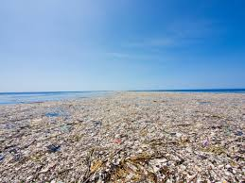

2. Reduce and eliminate the use of plastic
- Environmental & Ecosystem Destruction: Plastic pollution severely impacts biodiversity, altering habitats and natural processes. Over 70% of marine litter in certain seas is plastic, and millions of seabirds and marine mammals die annually from ingesting or becoming entangled in plastic debris.
- Human Health Hazards: Plastics contain harmful chemicals like phthalates, which can leach into food and water. These toxins can cause health problems, including respiratory issues, allergies, and disruption of endocrine systems.
- Microplastic Contamination: Plastics do not biodegrade, but break down into microplastics, which have infiltrated the entire food chain, soil, and air.
- Climate Change Contribution: Plastic production and disposal, such as incineration, contribute to greenhouse gas emissions, exacerbating the climate crisis.
- Ineffective Recycling: Plastic recycling is largely inefficient; thus, reducing consumption is the most effective approach to reducing waste.
- Resource Management: Plastic is primarily derived from non-renewable fossil fuels.
UNEP - UN Environment Programme +5
- Recycle soft plastic (several grocery stores collect plastic)
- Reuse and recycle plastic containers
- Avoid purchasing plastic products and opt for products that are not packaged in plastic
- Use tote bags for groceries
- Question the overuse of plastic by producers
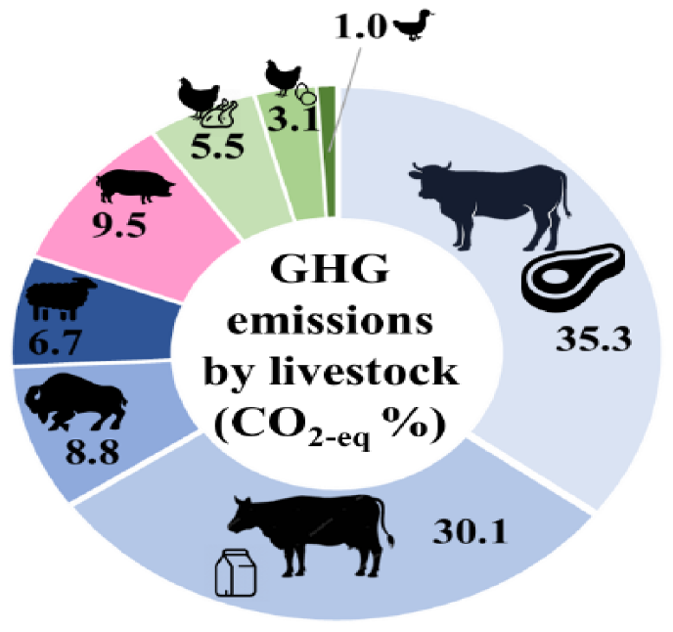
3. Consider one meatless meal a week (or more!)
Total Farmland: Approximately 80% of all U.S. agricultural land is dedicated to animal agriculture, including both grazing land and land used to grow feed crops.

Efficiency: While using 80% of farmland, livestock production provides only about 18% of food calories and 37% of protein in the American diet.

The "water footprint" of meat varies significantly by the type of animal produced:
Beef: Requires between 1,800 and 2,000 gallons of water per pound produced.
Pork: Uses approximately 720 gallons per pound.
Chicken: Uses approximately 520 gallons per pound.
Overall Impact: Agriculture accounts for 87% of all freshwater consumed in the U.S. annually, with a large portion of that used to irrigate livestock feed crops.
ARS, USDA (.gov) +4

Energy and Emissions
Fossil Fuels: Animal protein production in the U.S. requires an average of 28 kcal of fossil fuel energy for every 1 kcal of protein produced for human consumption.
Greenhouse Gases: Beef cattle production alone accounts for about 3.3% to 3.7% of all U.S. greenhouse gas emissions.
Comparative Impact: The greenhouse gas emissions from raising cattle in the U.S. are estimated to be higher than those from the entire domestic transportation sector (cars, trucks, planes, etc.).


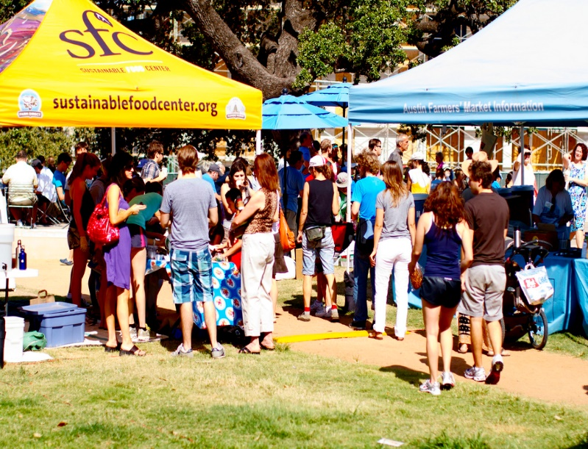

4. Buying locally

Locally sourced materials and products have many environmental benefits. They produce less waste by eliminating unnecessary transportation and delivery, therefore reducing the amount of packaging being used. Less packaging means less waste and less demand on landfill sites. According to the National Resource Defense Council, buying local will help reduce pollution, improve air quality and improve our health.
Michigan State University Center for Community and Economic Development

- Support grocery stores that sell locally produced food products
- Shop farm Market days
- Support community-based businesses

Join a Creation Care committee

Vine and Branches
St. Catherine of Siena-St. Lucy, St. Giles
Contact: Sister Sue Paweski spaweski@spsmw.org

Honoirng Our Mother Earth (H+O+M+E+)
Ascension-St. Edmund
Contact: Laura Kelly lkelly@ascensionoakpark.com

